Daily Reading for Saturday, April 8th, 2023
- Catholic Online

- Bible

Daily Reading for Saturday April 8, 2023
Reading 1, Genesis 1:1-2:2
Responsorial Psalm, Psalms 33:4-5, 6-7, 12-13, 20-22
Gospel, Matthew 28:1-10
Reading 2, Genesis 22:1-18
Printable PDF of Today's Reading
Past / Future Daily Readings
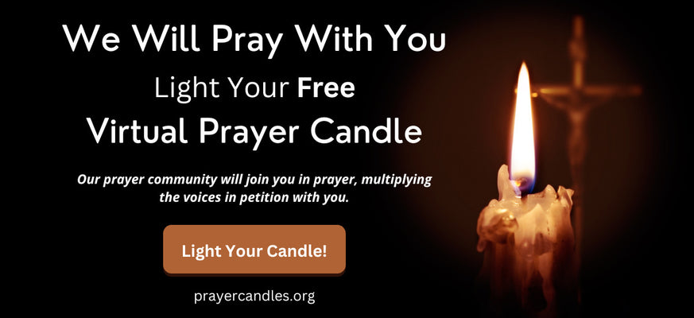

We will Pray with You - Light your free Virtual Prayer Candle

Reading 1, Genesis 1:1-2:2
¹ In the beginning God created heaven and earth.
² Now the earth was a formless void, there was darkness over the deep, with a divine wind sweeping over the waters.
³ God said, 'Let there be light,' and there was light.
⁴ God saw that light was good, and God divided light from darkness.
⁵ God called light 'day', and darkness he called 'night'. Evening came and morning came: the first day.
⁶ God said, 'Let there be a vault through the middle of the waters to divide the waters in two.' And so it was.
⁷ God made the vault, and it divided the waters under the vault from the waters above the vault.
⁸ God called the vault 'heaven'. Evening came and morning came: the second day.
⁹ God said, 'Let the waters under heaven come together into a single mass, and let dry land appear.' And so it was.
¹⁰ God called the dry land 'earth' and the mass of waters 'seas', and God saw that it was good.
¹¹ God said, 'Let the earth produce vegetation: seed-bearing plants, and fruit trees on earth, bearing fruit with their seed inside, each corresponding to its own species.' And so it was.
¹² The earth produced vegetation: the various kinds of seed-bearing plants and the fruit trees with seed inside, each corresponding to its own species. God saw that it was good.
¹³ Evening came and morning came: the third day.
¹⁴ God said, 'Let there be lights in the vault of heaven to divide day from night, and let them indicate festivals, days and years.
¹⁵ Let them be lights in the vault of heaven to shine on the earth.' And so it was.
¹⁶ God made the two great lights: the greater light to govern the day, the smaller light to govern the night, and the stars.
¹⁷ God set them in the vault of heaven to shine on the earth,
¹⁸ to govern the day and the night and to divide light from darkness. God saw that it was good.
¹⁹ Evening came and morning came: the fourth day.
²⁰ God said, 'Let the waters be alive with a swarm of living creatures, and let birds wing their way above the earth across the vault of heaven.' And so it was.
²¹ God created great sea-monsters and all the creatures that glide and teem in the waters in their own species, and winged birds in their own species. God saw that it was good.
²² God blessed them, saying, 'Be fruitful, multiply, and fill the waters of the seas; and let the birds multiply on land.'
²³ Evening came and morning came: the fifth day.
²⁴ God said, 'Let the earth produce every kind of living creature in its own species: cattle, creeping things and wild animals of all kinds.' And so it was.
²⁵ God made wild animals in their own species, and cattle in theirs, and every creature that crawls along the earth in its own species. God saw that it was good.
²⁶ God said, 'Let us make man in our own image, in the likeness of ourselves, and let them be masters of the fish of the sea, the birds of heaven, the cattle, all the wild animals and all the creatures that creep along the ground.'
²⁷ God created man in the image of himself, in the image of God he created him, male and female he created them.
²⁸ God blessed them, saying to them, 'Be fruitful, multiply, fill the earth and subdue it. Be masters of the fish of the sea, the birds of heaven and all the living creatures that move on earth.'
²⁹ God also said, 'Look, to you I give all the seed-bearing plants everywhere on the surface of the earth, and all the trees with seed-bearing fruit; this will be your food.
³⁰ And to all the wild animals, all the birds of heaven and all the living creatures that creep along the ground, I give all the foliage of the plants as their food.' And so it was.
³¹ God saw all he had made, and indeed it was very good. Evening came and morning came: the sixth day.
¹ Thus heaven and earth were completed with all their array.
² On the seventh day God had completed the work he had been doing. He rested on the seventh day after all the work he had been doing.

Responsorial Psalm, Psalms 33:4-5, 6-7, 12-13, 20-22
⁴ The word of Yahweh is straightforward, all he does springs from his constancy.
⁵ He loves uprightness and justice; the faithful love of Yahweh fills the earth.
⁶ By the word of Yahweh the heavens were made, by the breath of his mouth all their array.
⁷ He collects the waters of the sea like a dam, he stores away the abyss in his treasure-house.
¹² How blessed the nation whose God is Yahweh, the people he has chosen as his heritage.
¹³ From heaven Yahweh looks down, he sees all the children of Adam,
²⁰ We are waiting for Yahweh; he is our help and our shield,
²¹ for in him our heart rejoices, in his holy name we trust.
²² Yahweh, let your faithful love rest on us, as our hope has rested in you.

We ask you, humbly: don't scroll away.
Hi readers, it seems you use Catholic Online a lot; that's great! It's a little awkward to ask, but we need your help. If you have already donated, we sincerely thank you. We're not salespeople, but we depend on donations averaging $14.76 and fewer than 1% of readers give. If you donate just $5.00, the price of your coffee, Catholic Online School could keep thriving. Thank you.
Help Now >

Gospel, Matthew 28:1-10
¹ After the Sabbath, and towards dawn on the first day of the week, Mary of Magdala and the other Mary went to visit the sepulchre.
² And suddenly there was a violent earthquake, for an angel of the Lord, descending from heaven, came and rolled away the stone and sat on it.
³ His face was like lightning, his robe white as snow.
⁴ The guards were so shaken by fear of him that they were like dead men.
⁵ But the angel spoke; and he said to the women, 'There is no need for you to be afraid. I know you are looking for Jesus, who was crucified.
⁶ He is not here, for he has risen, as he said he would. Come and see the place where he lay,
⁷ then go quickly and tell his disciples, "He has risen from the dead and now he is going ahead of you to Galilee; that is where you will see him." Look! I have told you.'
⁸ Filled with awe and great joy the women came quickly away from the tomb and ran to tell his disciples.
⁹ And suddenly, coming to meet them, was Jesus. 'Greetings,' he said. And the women came up to him and, clasping his feet, they did him homage.
¹⁰ Then Jesus said to them, 'Do not be afraid; go and tell my brothers that they must leave for Galilee; there they will see me.'

Reading 2, Genesis 22:1-18
¹ It happened some time later that God put Abraham to the test. 'Abraham, Abraham!' he called. 'Here I am,' he replied.
² God said, 'Take your son, your only son, your beloved Isaac, and go to the land of Moriah, where you are to offer him as a burnt offering on one of the mountains which I shall point out to you.'
³ Early next morning Abraham saddled his donkey and took with him two of his servants and his son Isaac. He chopped wood for the burnt offering and started on his journey to the place which God had indicated to him.
⁴ On the third day Abraham looked up and saw the place in the distance.
⁵ Then Abraham said to his servants, 'Stay here with the donkey. The boy and I are going over there; we shall worship and then come back to you.'
⁶ Abraham took the wood for the burnt offering, loaded it on Isaac, and carried in his own hands the fire and the knife. Then the two of them set out together.
⁷ Isaac spoke to his father Abraham. 'Father?' he said. 'Yes, my son,' he replied. 'Look,' he said, 'here are the fire and the wood, but where is the lamb for the burnt offering?'
⁸ Abraham replied, 'My son, God himself will provide the lamb for the burnt offering.' And the two of them went on together.
⁹ When they arrived at the place which God had indicated to him, Abraham built an altar there, and arranged the wood. Then he bound his son and put him on the altar on top of the wood.
¹⁰ Abraham stretched out his hand and took the knife to kill his son.
¹¹ But the angel of Yahweh called to him from heaven. 'Abraham, Abraham!' he said. 'Here I am,' he replied.
¹² 'Do not raise your hand against the boy,' the angel said. 'Do not harm him, for now I know you fear God. You have not refused me your own beloved son.'
¹³ Then looking up, Abraham saw a ram caught by its horns in a bush. Abraham took the ram and offered it as a burnt offering in place of his son.
¹⁴ Abraham called this place 'Yahweh provides', and hence the saying today: 'On the mountain Yahweh provides.'
¹⁵ The angel of Yahweh called Abraham a second time from heaven.
¹⁶ 'I swear by my own self, Yahweh declares, that because you have done this, because you have not refused me your own beloved son,
¹⁷ I will shower blessings on you and make your descendants as numerous as the stars of heaven and the grains of sand on the seashore. Your descendants will gain possession of the gates of their enemies.
¹⁸ All nations on earth will bless themselves by your descendants, because you have obeyed my command.'

